Article Title

(Written in Times New Roman, Bold, Size 16, concisely, clearly, and specifically, maximum 15–20 words)

First Author1, Second Author2, Third Author3*(TNR 11 pt, BOLD)

1,2,3 Institution, City, Country
*Corresponding author: email (TNR, 10pt)

Received:  xxx | Revised:  xxx | Accepted:  xxx | Published:  xxx

ABSTRACT
The abstract is a concise summary of the entire community service article. This section should provide readers with a brief overview of the community service activity, including the partner’s problems, target participants/partners, objectives of the community service activity, methods/forms of activities implemented, key results, and the impacts/benefits of the activity for the partners. An effective abstract enables readers to quickly understand the purpose and significance of the activity without reading the full article. The abstract is usually written in a single paragraph and is approximately 150–250 words long.

Keywords: should provide three to five keywords that are specific, relevant, and closely related to the topic of the community service activity.

INTRODUCTION

Journal articles consist of Introduction, Implementation Method, Results and Discussion, Conclusion, and References. Journal articles should be written on A4 paper (21 cm × 29.7 cm) using Normal margins. The manuscript should use Times New Roman, 12-point font, single spacing, and justified alignment. Journal article submissions must be prepared and submitted in Microsoft Word (MS Word) format. The length of the article should be a minimum of 5 pages and a maximum of 15 pages.
The Introduction should include: an overview of the conditions and characteristics of the partners/target community; the main problems faced by the partners; the rationale for conducting the community service activity; the solutions offered to address the partners’ problems; the objectives of the community service activity; and relevant references to support the discussion.

IMPLEMENTATION METHOD
This section explains how the community service activity is implemented, including: the location and time of the activity; partners or target participants; number of participants, if relevant; stages of activity implementation; methods used, such as socialization, outreach, training, mentoring, workshops, hands-on practice, demonstrations, or other methods; media/instruments used; and methods for evaluating the success of the activity, if applicable.
The stages of the activity can be presented in a simple sequence, for example: problem identification → preparation → implementation → mentoring → evaluation.
Section titles should be written in Times New Roman, uppercase letters, 12 pt, and bold. Subsection titles should be written in Times New Roman, 12 pt, and bold. Section and subsection titles should not be numbered. This section may be supplemented with a chart or schematic diagram illustrating the stages of activity implementation.
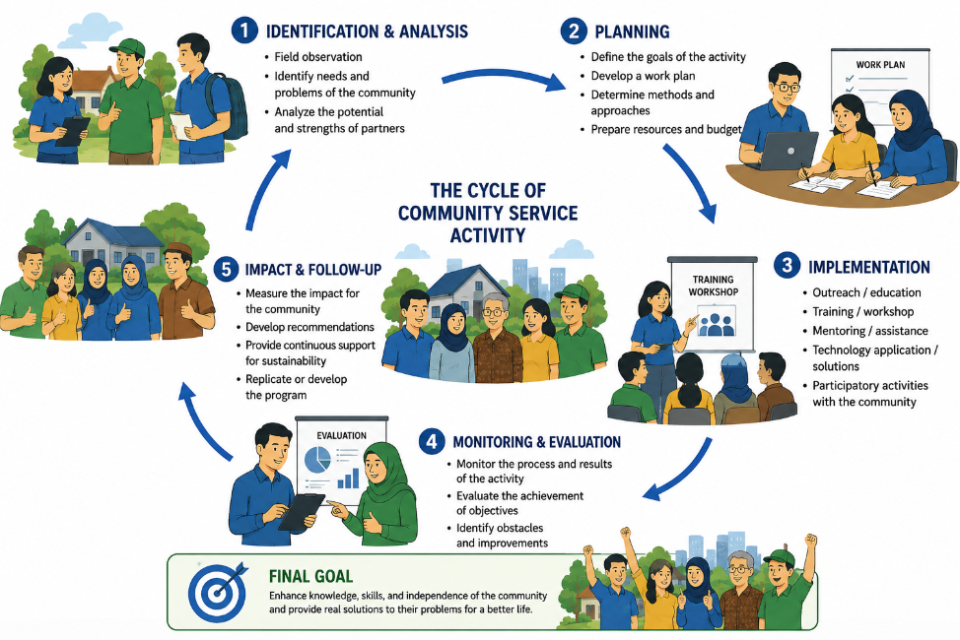

Figure 1. Flow xx
Resource: xx(202x)

DISCUSSIONS
This section is the main part of the article and should include: the implementation of the activities; the results obtained from each stage of the activities; responses and participation of partners/participants; changes in the partners’ knowledge, skills, capabilities, or conditions after the activities; results of the activity evaluation, if conducted; challenges encountered during implementation and how they were addressed; and a discussion of the results by relating the outcomes of the community service activities to relevant references or previous community service activities. Documentation in the form of photographs, tables, graphs, or figures may be included to support and strengthen the results.
Important: The results of the community service activities should not merely state that “the activities were successfully implemented” but should clearly demonstrate the outcomes or changes experienced by the partners.
Table 1. Data XXX
No | Name | Transactions (Rp) | Total Amount (Rp)
1 | Arnadi | 5,000,000 | 5,000,000
 |  |  | 5,000,000
Source: xx (202x)

CONCLUSION

This section should be written concisely in paragraph form and should include the achievement of the objectives of the community service activity, the main results obtained, and the benefits or impacts of the activity on the partners. The conclusion should not merely repeat the description of the activities but should emphasize the outcomes and benefits gained by the partners. Recommendations may include follow-up activities, further assistance needed by the partners, the development of future community service programs, and efforts to ensure the sustainability of the activity outcomes.

ACKNOWLEDGMENTS
If applicable, acknowledgments may be given to: funding institutions; community service partners; and other institutions or parties that supported the implementation of the community service activities.

REFERENCES
References should preferably be managed using a reference management application, such as EndNote or Mendeley. The reference list should be provided at the end of the article using APA Style and arranged alphabetically by the last name of the first author. References should be relevant to the problems addressed and the community service activities conducted, with priority given to relevant and relatively recent scholarly sources. The reference list should be written in Times New Roman, 12 pt, using a 10 mm hanging indent. APA Style guidelines are available on the official APA Style website.

For Books, the format is as follows: Author's Last Name, First Name Initials. (Publication Year). Book title (in Italics). Edition (If applicable). Publisher Name. City. Example :

Judijanto, L., Ohyver, D.A., Kusumastuti, S.Y., & Masri, M. (2025). Literasi Keuangan (Teori dan Implementasi). Sonpedia Publishing Indonesia, Jambi.

For Journal Articles, the format is as follows: Author's Last Name, First Name Initials. (Publication Year). Article Title. Journal Name (in Italics). Volume. Issue: Pages (From-to). Example :

Femilia, D., & Wikartika, I. (2025). Peningkatan Literasi Keuangan Digital Melalui Pendampingan Pembukaan Rekening Online Bank XXX. Jurnal Abdimas Kartika Wijayakusuma. 6(1): 255-264. https://doi.org/10.26874/jakw.v6i1.725

Putri, A.M., & Iryanti, E. (2026). Peningkatan Literasi Keuangan UMKM melalui Pendampingan Pencatatan Keuangan Terintegrasi di Kelurahan Kejawan Putih Tambak. Jurnal Pengabdian Kepada Masyarakat Nusantara. 7(1): 939-947. https://ejournal.sisfokomtek.org/index.php/jpkm/article/view/8069

Martina, S., Sriwiyanti, E., Purba, D.S., Tarigan, V., Saragih, M., Tarigan, W. J., Azhari, T., & Aulia, R. (2025). Pendampingan Literasi Keuangan Syariah Bagi Wirausaha Muda Melalui Pendekatan Service Learning. Jurnal Pengabdian Masyarakat Sapangambei Manoktok Hitei. 5(2): 523-528. https://doi.org/10.36985/gqamrs36

